Screen Shot 1:-

1. Listing all the Customers in the database:-

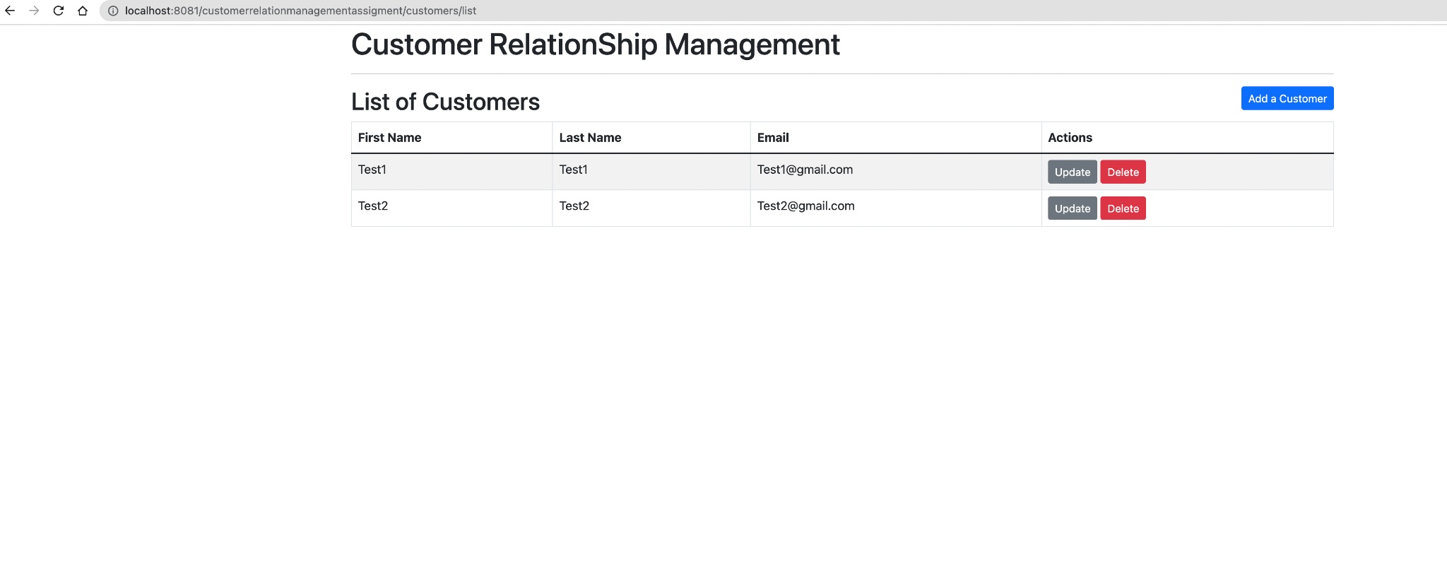

1. Screen to add a customer in the database:-

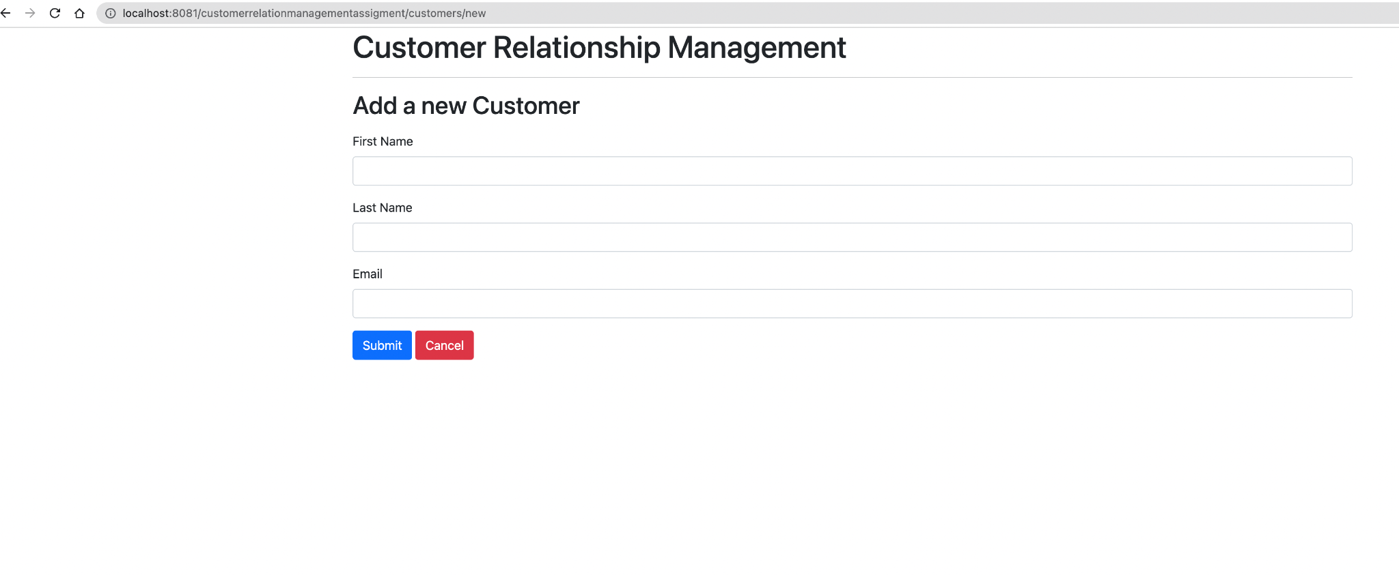

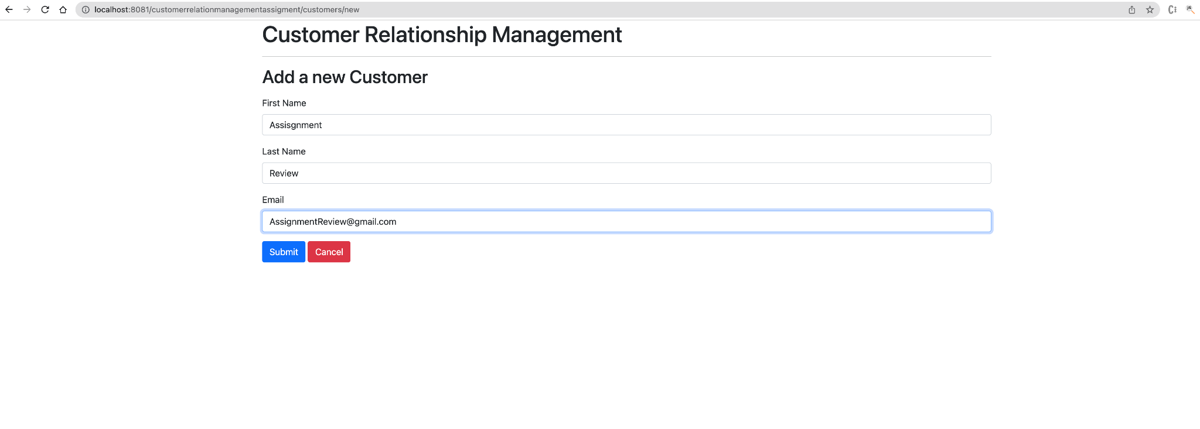

Updated List of Customers

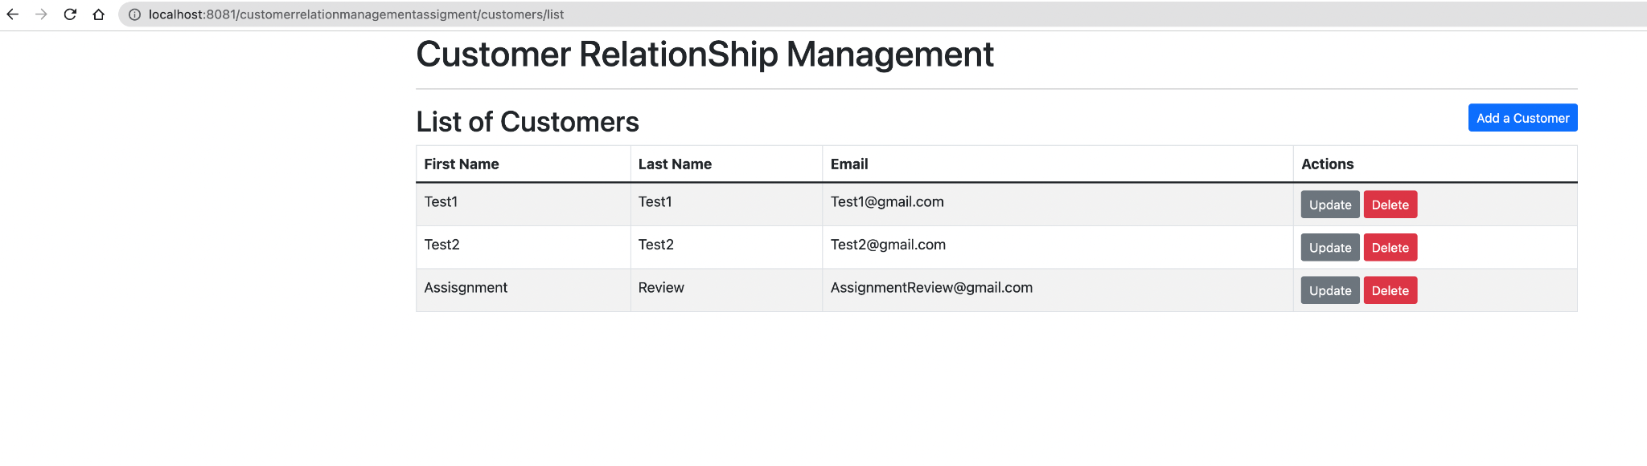

1. Screenshot after clicking the update Button:-

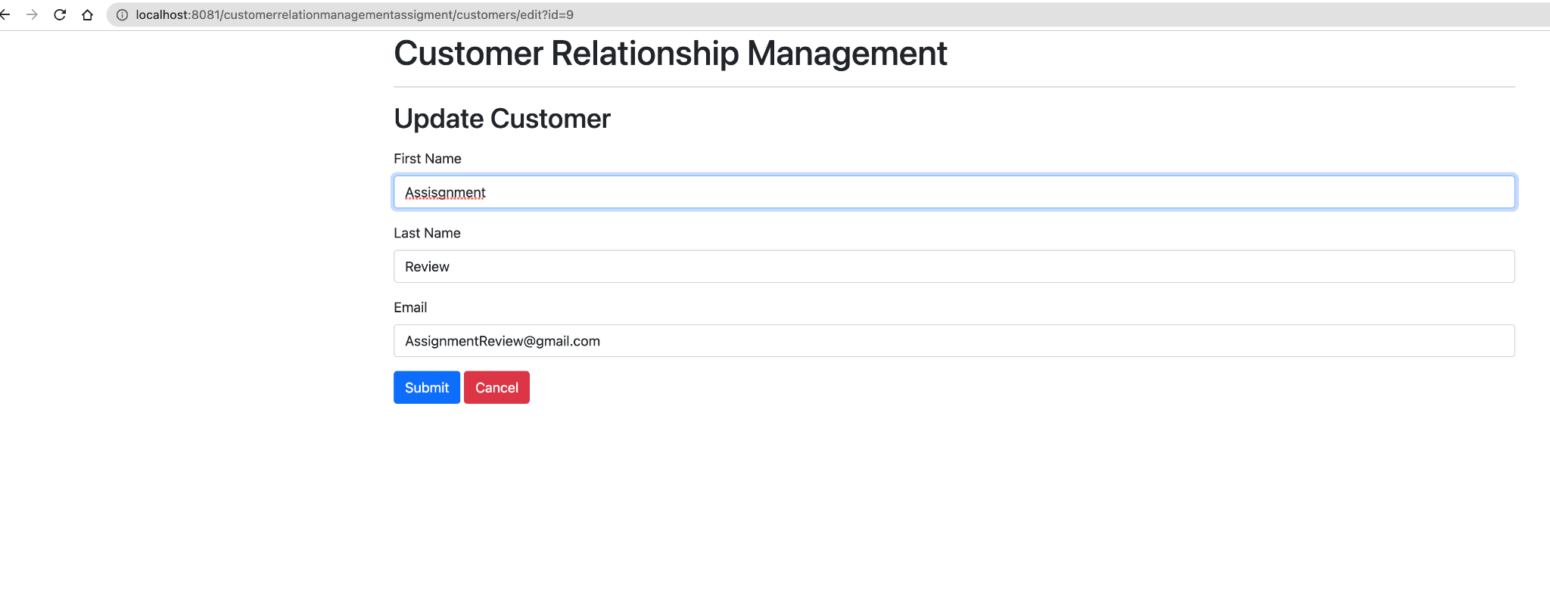

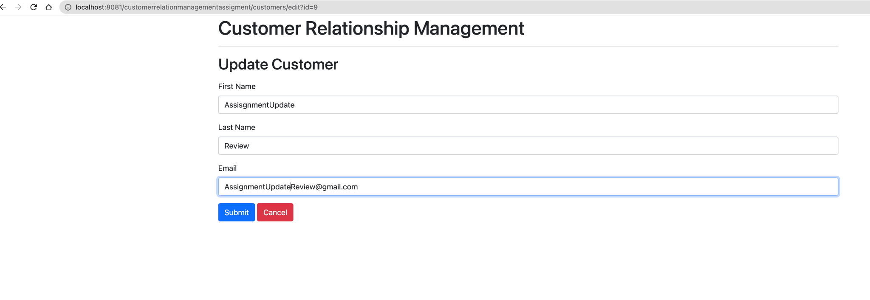

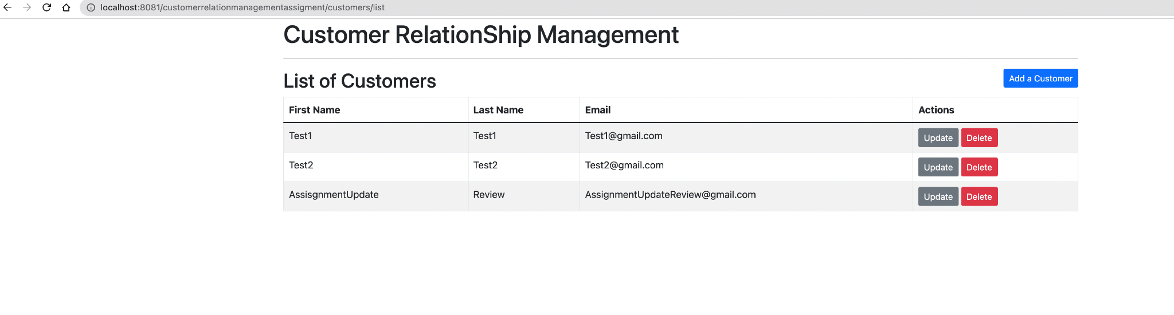

1. Screenshot of list of Customers After deleting the customer ‘AssignmentUpdate’:-

